*//Q1. WACP that can maintain the name, roll, number*

*//and marks of a class of students. The size of the class is variable.*

*// Include func- tion to compute the average marks of the class.*

*#include*<stdio.h>

int average(int sum, int n);

int main(){

int n,i,sum=0;

printf("Enter the size of the class: ");

scanf("%d", &n);

struct class{

char name[20];

int roll;

int marks;

}c[n];

*for*(i=0; i<n; i++){

printf("Enter student %d name: ", i+1);

scanf("%s", c[i].name);

printf("Enter student %d roll: ", i+1);

scanf("%d", &c[i].roll);

printf("Enter student %d marks: ", i+1);

scanf("%d", &c[i].marks);

sum+=c[i].marks;

printf("\n");

}

printf("Student's Information:\n\n");

printf("|| Name || Roll No. || Marks ||");

printf("\n_______________________________________________\n");

*for*(i=0; i<n; i++){

printf("||%9s ||%8d ||%8d ||\n", c[i].name, c[i].roll, c[i].marks);

}

printf("\nThe average marks of the class is %d\n", average(sum,n));

*return* 0;

}

int average(int sum, int n){*//function to calculate the average.*

int avg = sum/n;

*return* avg;

}

**Output:**

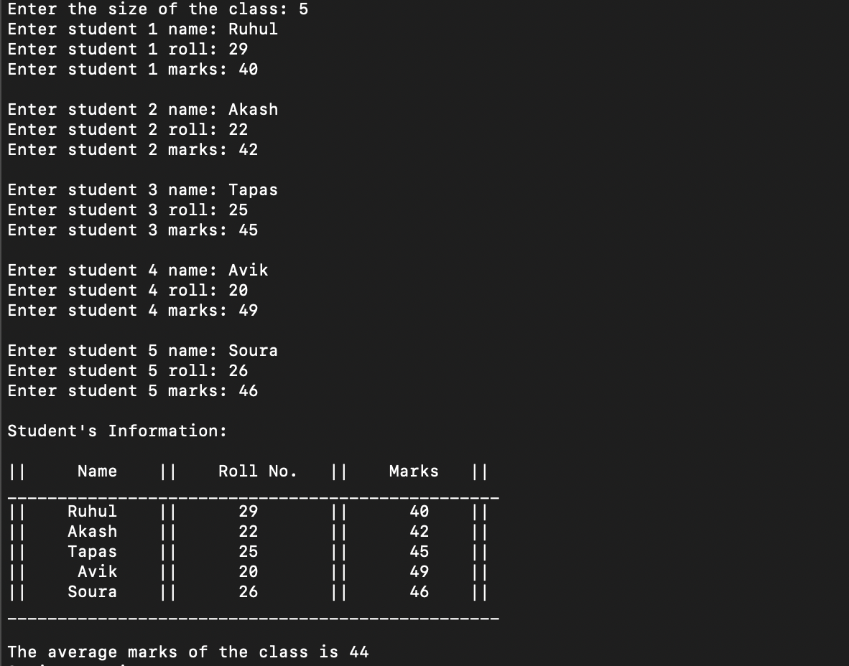

*//Q2. Define a structure called “cricket” that will describe the*

*//following information -*

*//Player name, Team name, Batting average.*

*//using “cricket” declare an array “player” with 50 elements and*

*//write a program to read the information about all the 50 players*

*// and print a team wise list containing names of players with their*

*// batting average.*

*#include*<stdio.h>

int main(){

int i,Team;

struct cricket{

char player_name[20];

char team_name[2];

float batting_avg;

}player[50];

*for*(i=0; i<50; i++){

printf("\nEnter player %d name: ", i+1);

scanf("%s", player[i].player_name);

printf("\nEnter player %d team(A/B): ", i+1);

scanf("%s", player[i].team_name);

printf("\nEnter player %d batting average: ", i+1);

scanf("%f", &player[i].batting_avg);

}

printf("\nTeam A player's info:\n");

printf("|| Name || Batting Average ||");

printf("\n__________________________________________\n");

*for*(i=0; i<50; i++){

*if*(*player[i].team_name=='A'){

printf("||%9s || %.2f ||\n", player[i].player_name, player[i].batting_avg);

}

}

printf("\n__________________________________________\n");

printf("\n\nTeam B player's info:\n");

printf("|| Name || Batting Average ||");

printf("\n__________________________________________\n");

*for*(i=0; i<50; i++){

*if*(*player[i].team_name=='B'){

printf("||%9s || %.2f ||\n", player[i].player_name, player[i].batting_avg);

}

}

printf("\n__________________________________________\n");

*return* 0;

}

**Output:**

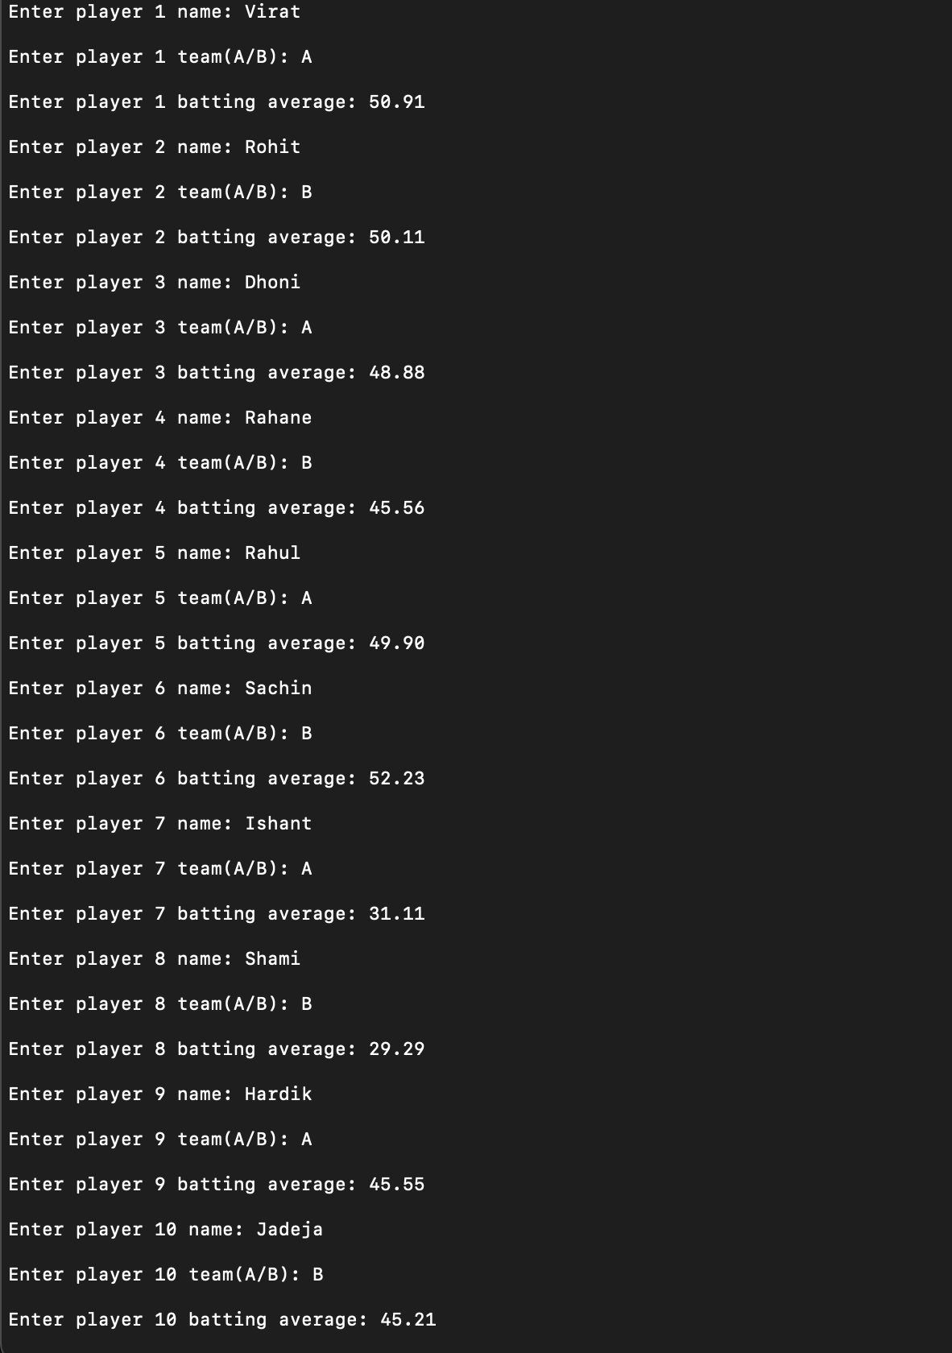

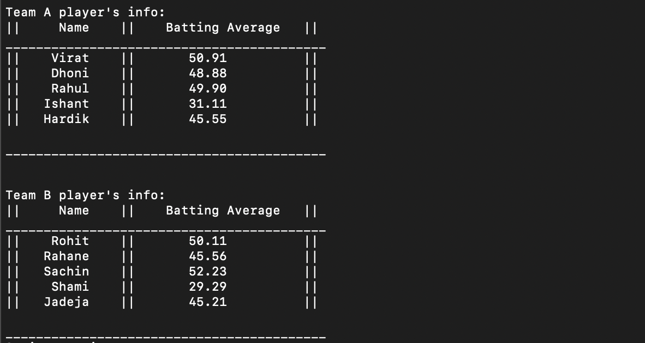

*//Q3. Write a program to illustrate the use of arrays within*

*//a structure using dynamic memory allocation.*

*#include*<stdio.h>

*#include*<stdlib.h>

struct student

{

char name[20];

int roll;

};

int main()

{

struct student *s;

int i,n;

printf("Enter the number of records you wish to enter: ");

scanf("%d",&n);

s = (struct student*)malloc(n*sizeof(struct student));

*for*(i=0;i<n;i++)

{

printf("Enter the roll number and name of student no. %d: ", i+1);

scanf("%d %s",&(s+i)->roll,(s+i)->name);

}

printf("Now showing the students info:\n");

printf("| Roll | Name |\n");

printf("___________________________________\n");

*for*(i=0;i<n;i++)

{

printf("|%4d |%12s |\n",(s+i)->roll,(s+i)->name);

}

printf("___________________________________\n");

*return* 0;

}

**Output:**

